CN Project Report

Personalized Network

**Making a secure network using VLAN technology**

Submitted to:

Dr. Ali Hammad Akbar

Submitted by:

2016-CS-122

2016-CS-178

**Abstract**:

The project is to understand the advantages of using VLAN in a network, how broadcasting is controlled. Understand the configuration which is required to setup a VLAN based network using Cisco routers and switches.

The main goal of this work is to increase the security level of the LAN, in order to reduce the access to undesirable sites and to avoid the presence of hackers in the internet.

Key-Words: - LAN, VLAN, security, Internet, TCP, switching, RIPv2, Router, Switch.

**Hardware:**

Cisco router and cisco switch which supports VLANs.

**Software:**

**Cisco packet tracer:**

Packet Tracer is a cross-platform visual simulation program designed by Cisco Systems that allows users to create network topologies and imitate modern computer networks. The software allows users to simulate the configuration of Cisco routers and switches using a simulated command line interface

**Introduction:**

The Local Area Network (LAN) is widely used because a large number of applications imply some user in the same broadcast domain. There is kind of LAN named virtual LAN (VLAN), in this sort of network a group of hosts with a set of common requirements provides communication. It is important to emphasize that the group of hosts should be in the same broadcast domain, despite the same place

Other networks like Metropolitan Area Network (MAN) or Wide Area Network (WAN) are not compatible with virtual technologies, because the elements of the VLAN normally share routing and switching.

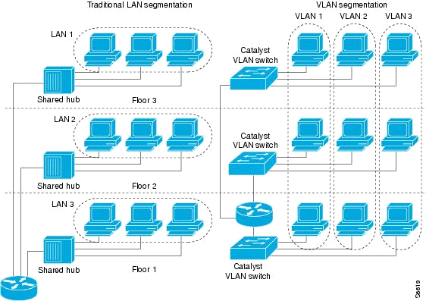

**Difference between Traditional LAN Segmentation and VLAN Segmentation**

**VLAN:**

A virtual LAN (VLAN) abstracts the idea of the LAN; A VLAN might comprise a subset of the ports on a single switch or subsets of ports on multiple switches. By default, systems on one VLAN don't see the traffic associated with systems on other VLANs on the same network.

VLANs allow network administrators to partition their networks to match the functional and security requirements of their systems without having to run new cables or make major changes in their current network infrastructure. IEEE 802.1Q is the standard defining VLANs; the VLAN identifier or tag consists of 12 bits in the Ethernet frame, creating an inherent limit of 4,096 VLANs on a LAN.

**Use Case:**

We are using Enterprises Network Model to show the use case of Vlan and how Real Scenario works when Different Branches of Enterprises are located in Different Cities.

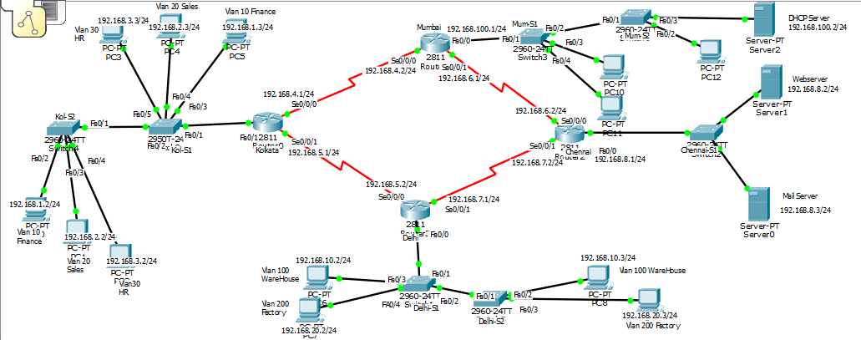

**Cisco Packet Tracer Network Diagram**

**This is an organization where we have offices located in four metropolitan cities-:**

Network consists of a four locations,

1. Kolkata

2. New Delhi

3. Mumbai

4. Chennai

1. The Kolkata location has 3 VLANS. They are VLAN 10(Sales), VLAN 20(Finance) and VLAN 30(HR). The “kolkata router” is configured with proper banner and enabled secret as 'kolkata@cisco' and VTY password as 'cisco'.
2. The Delhi location has 2 VLANs. They are VLAN 100(WareHouse) and VLAN 200(Factory). Delhi router is configured with proper banner and enable secret as 'delhi@cisco', VTY password as 'cisco'.
3. The Chennai location contains the Webserver(192.168.8.2/24) and the Mail server(192.168.8.3/24).Chennai router is configured with proper banner and enable secret as 'chennai@cisco' and VTY password as 'cisco'.

1. The Mumbai location has only the office LAN in 192.168.100.0/24 subnet and each computer is getting IP address from the DHCP Server 192.168.1002/24. Mumbai router is configured with a proper banner. The enable secret is 'mumbai@cisco’ and VTY password is 'cisco'.
2. Kolkata, Delhi and Mumbai location is connected via Point-to-Point leased line.
3. Users of all regions except the Factory VLAN will have access to Web Server and Mail server.
4. Inter VLAN routing has been performed and RIPv2 is used as the routing protocol.

**VLAN IP:**

**VLAN 10 (Finance) -- 192.168.1.0/24 VLAN 20(Sales) - 192.168.2.0/24**

**VLAN 30 (HR) -- 192.168.3.0/24 VLAN 100 (WareHouse) - 192.168.10.0/24**

**VLAN 200 (Factory) -- 192.168.20.0/24**

**LAN IP:**

**Chennai LAN - 192.168.8.0/24**

**Mumbai LAN - 192.168.100.0/24**

**WAN IP:**

**Kolkata to Delhi WAN - 192.168.5.0/24**

**Kolkata to Mumbai WAN - 192.168.4.0/24**

**Chennai to Mumbai WAN- 192.168.6.0/24**

**Chennai to Delhi WAN --192.168.7.0/24**

**Conclusions:**

In this Project, the design and implementation of a VLAN is carried out. The main goals is: to optimize the network resources, to give security and to provide a real-time users monitoring, in order to avoid time wasting. As a result of this work, the solution implemented can be changed according to current organization requirements. This is especially useful, because the workstations can be easily relocated if necessary.

References:

1. Andrew S. Tanenbaum, Computer Networks, Prentice Hall, Fourth Edition, 2002.

2. <https://en.wikipedia.org/wiki/Virtual_LAN>

3. http://searchnetworking.techtarget.com/tutorial/VLAN-guide-for-networking-professionals